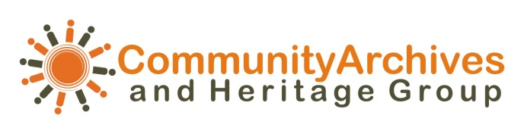

North West Conference
Chorley Town Hall

Wednesday 15ST OCTOBER, 2014

9.15-9.40am | Tea / Coffee on arrival
9.45am | Welcome address  Mayor of Chorley, Roy Lees
9.50am | Chorley Heritage Centre Support Group  Lincoln Shields  Chair (CHCSG)
10am | Introduction to CAHG  Julie Creer, Committee member CAHG
10.10am | Neil Sayer, Access Archivist  Heather Davis, Conservation Manager  Fiona McIntyre, Community Heritage Manager  Andrew Scofield, North West Sound Archives
11:10am | Comfort break
11:25am | Funding opportunities  Rebecca Mason  The Heritage Lottery Fund offers a range of different programmes with grants starting from £3,000, all of which are suitable for community archive projects. Rebecca will be looking at some of these programmes along with examples of funded projects
12:10pm | Lunch – Networking opportunities
1:25pm | Bill Walker CHCSG  “Celebrating Community Archives and Heritage”  Collaboration has been central to the rapid raising of awareness about heritage and the promising campaign to secure a physical heritage centre at the heart of Chorley. Bill's presentation will focus mainly on the partnership working with the University of Central Lancashire. Undergraduates from their Community History and Heritage Course
1:40pm | Chinese Archives Manchester  Jenny Wong  Manchester’s Chinese community numbers over 40,000 people, but there was little awareness of its heritage in the city. The Manchester Chinese Centre decided to address this by creating a new archive that shares this part of local history. Over 40 Manchester residents from a range of local communities – including Jewish, Malaysian, Vietnamese and Taiwanese – took part in the project. They were trained in oral history skills and recorded the memories of 55 Chinese people eager to challenge stereotypes and tell their stories of living in the city.
2:00pm | Portraits of the past  Cath Ford  Mid Pennine Arts brings art, people and places together to transform perceptions and change lives. MPA works through collaboration to create high quality art in response to the rich diverse contexts of NW England. MPA also specialises in using art as a tool for creative learning and community engagement projects with people of all ages. The idea for the Portraits of the Past project came out of Flicker, an installation at Gawthorpe Hall during 2013, which was part of MPA’s flagship programme Contemporary Heritage that places site-specific contemporary art installations in heritage venues
2.20pm | Comfort Break
2:30pm | Wikipedia and community participation  Wikipedia and community participation  Andy Mabbett  Andy, recently Wikipedian in Residence with Lancashire County Council's Museum Service, will talk about how your community projects could become involved in making knowledge freely available through Wikipedia, in collaboration with the international community of Wikipedia contributors.
2 : 45pm | Chorley Pals memorial project  Steve Williams  Steve will talk about the three year funding campaign that resulted in a memorial and statue being unveiled in 2010. Along with the continuation and legacy of the project  The Chorley Pals Memorial is situated on Union Street in Chorley, Lancashire, overlooking the town’s market (“The Flat Iron”) where the local ‘Pals’ Company paraded in 1914 and 1915, before setting off to war and into the pages of history at the Battle of the Somme on the 1st July 1916.
3 pm-3:30pm | Closing comments  Close

