

St Ann’s, Ashton
Fr Crombleholme and the 1868 Murphy Riots

Friday & Saturday 13 & 14 September 2013 : 10am-4pm

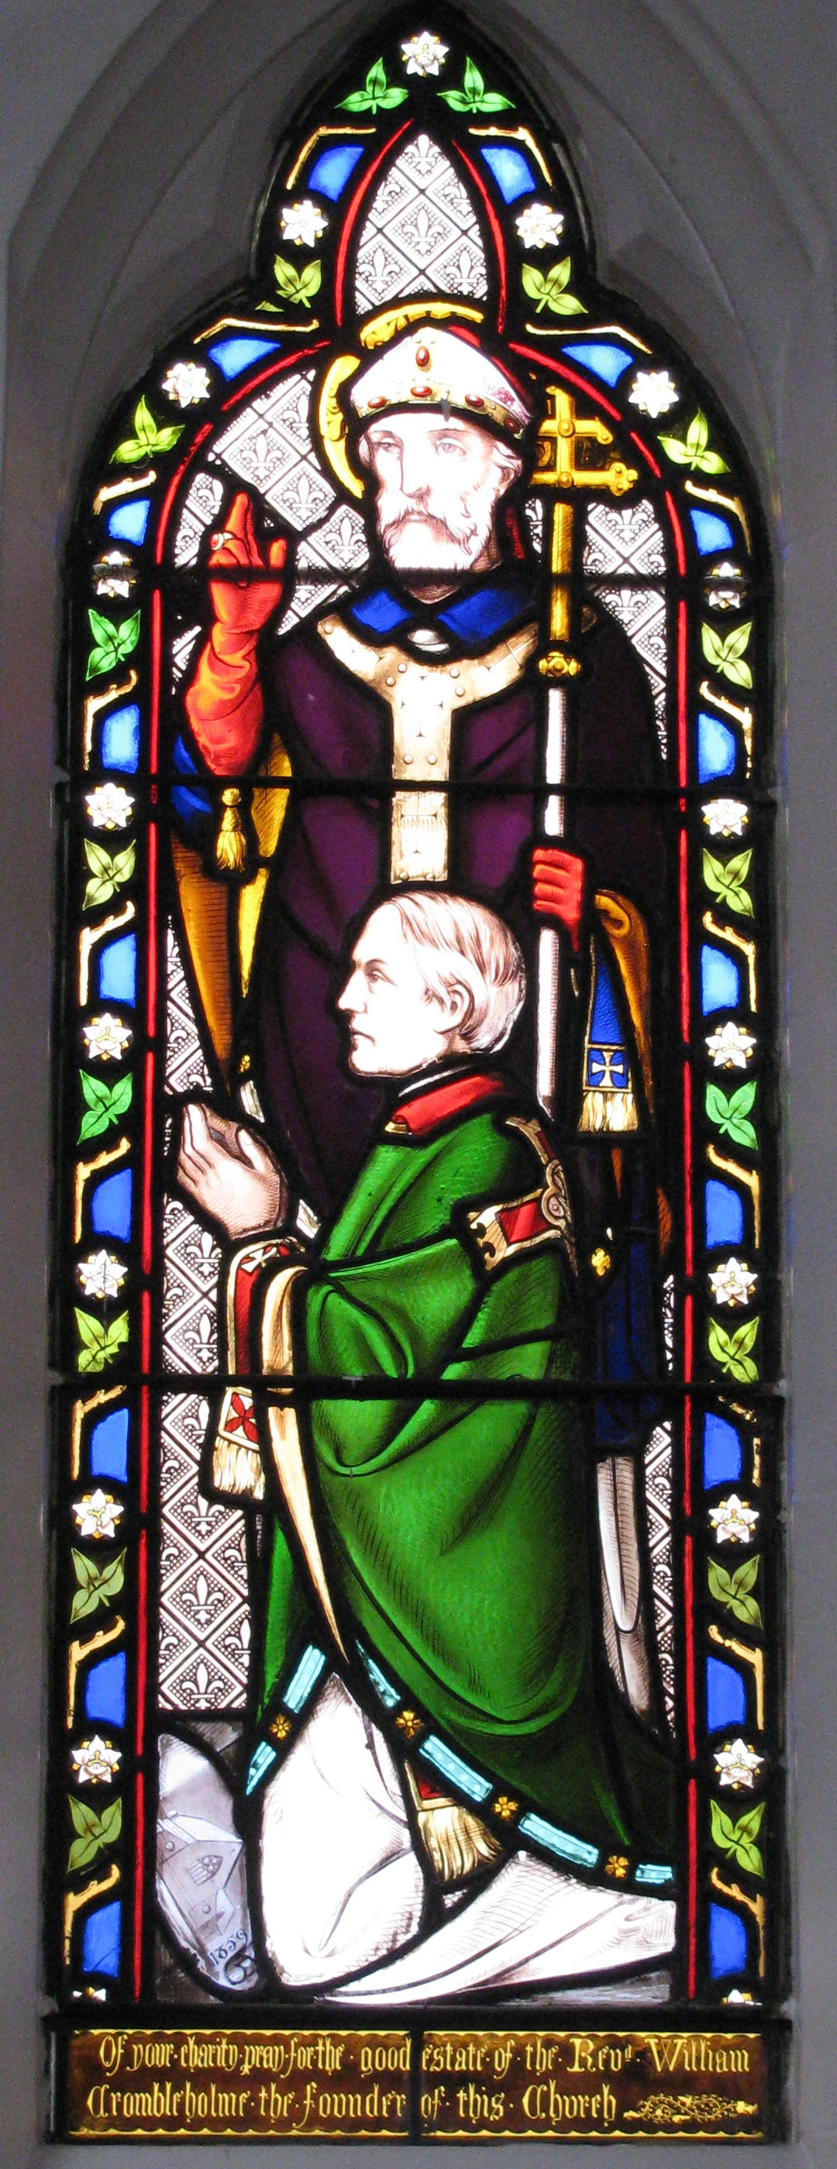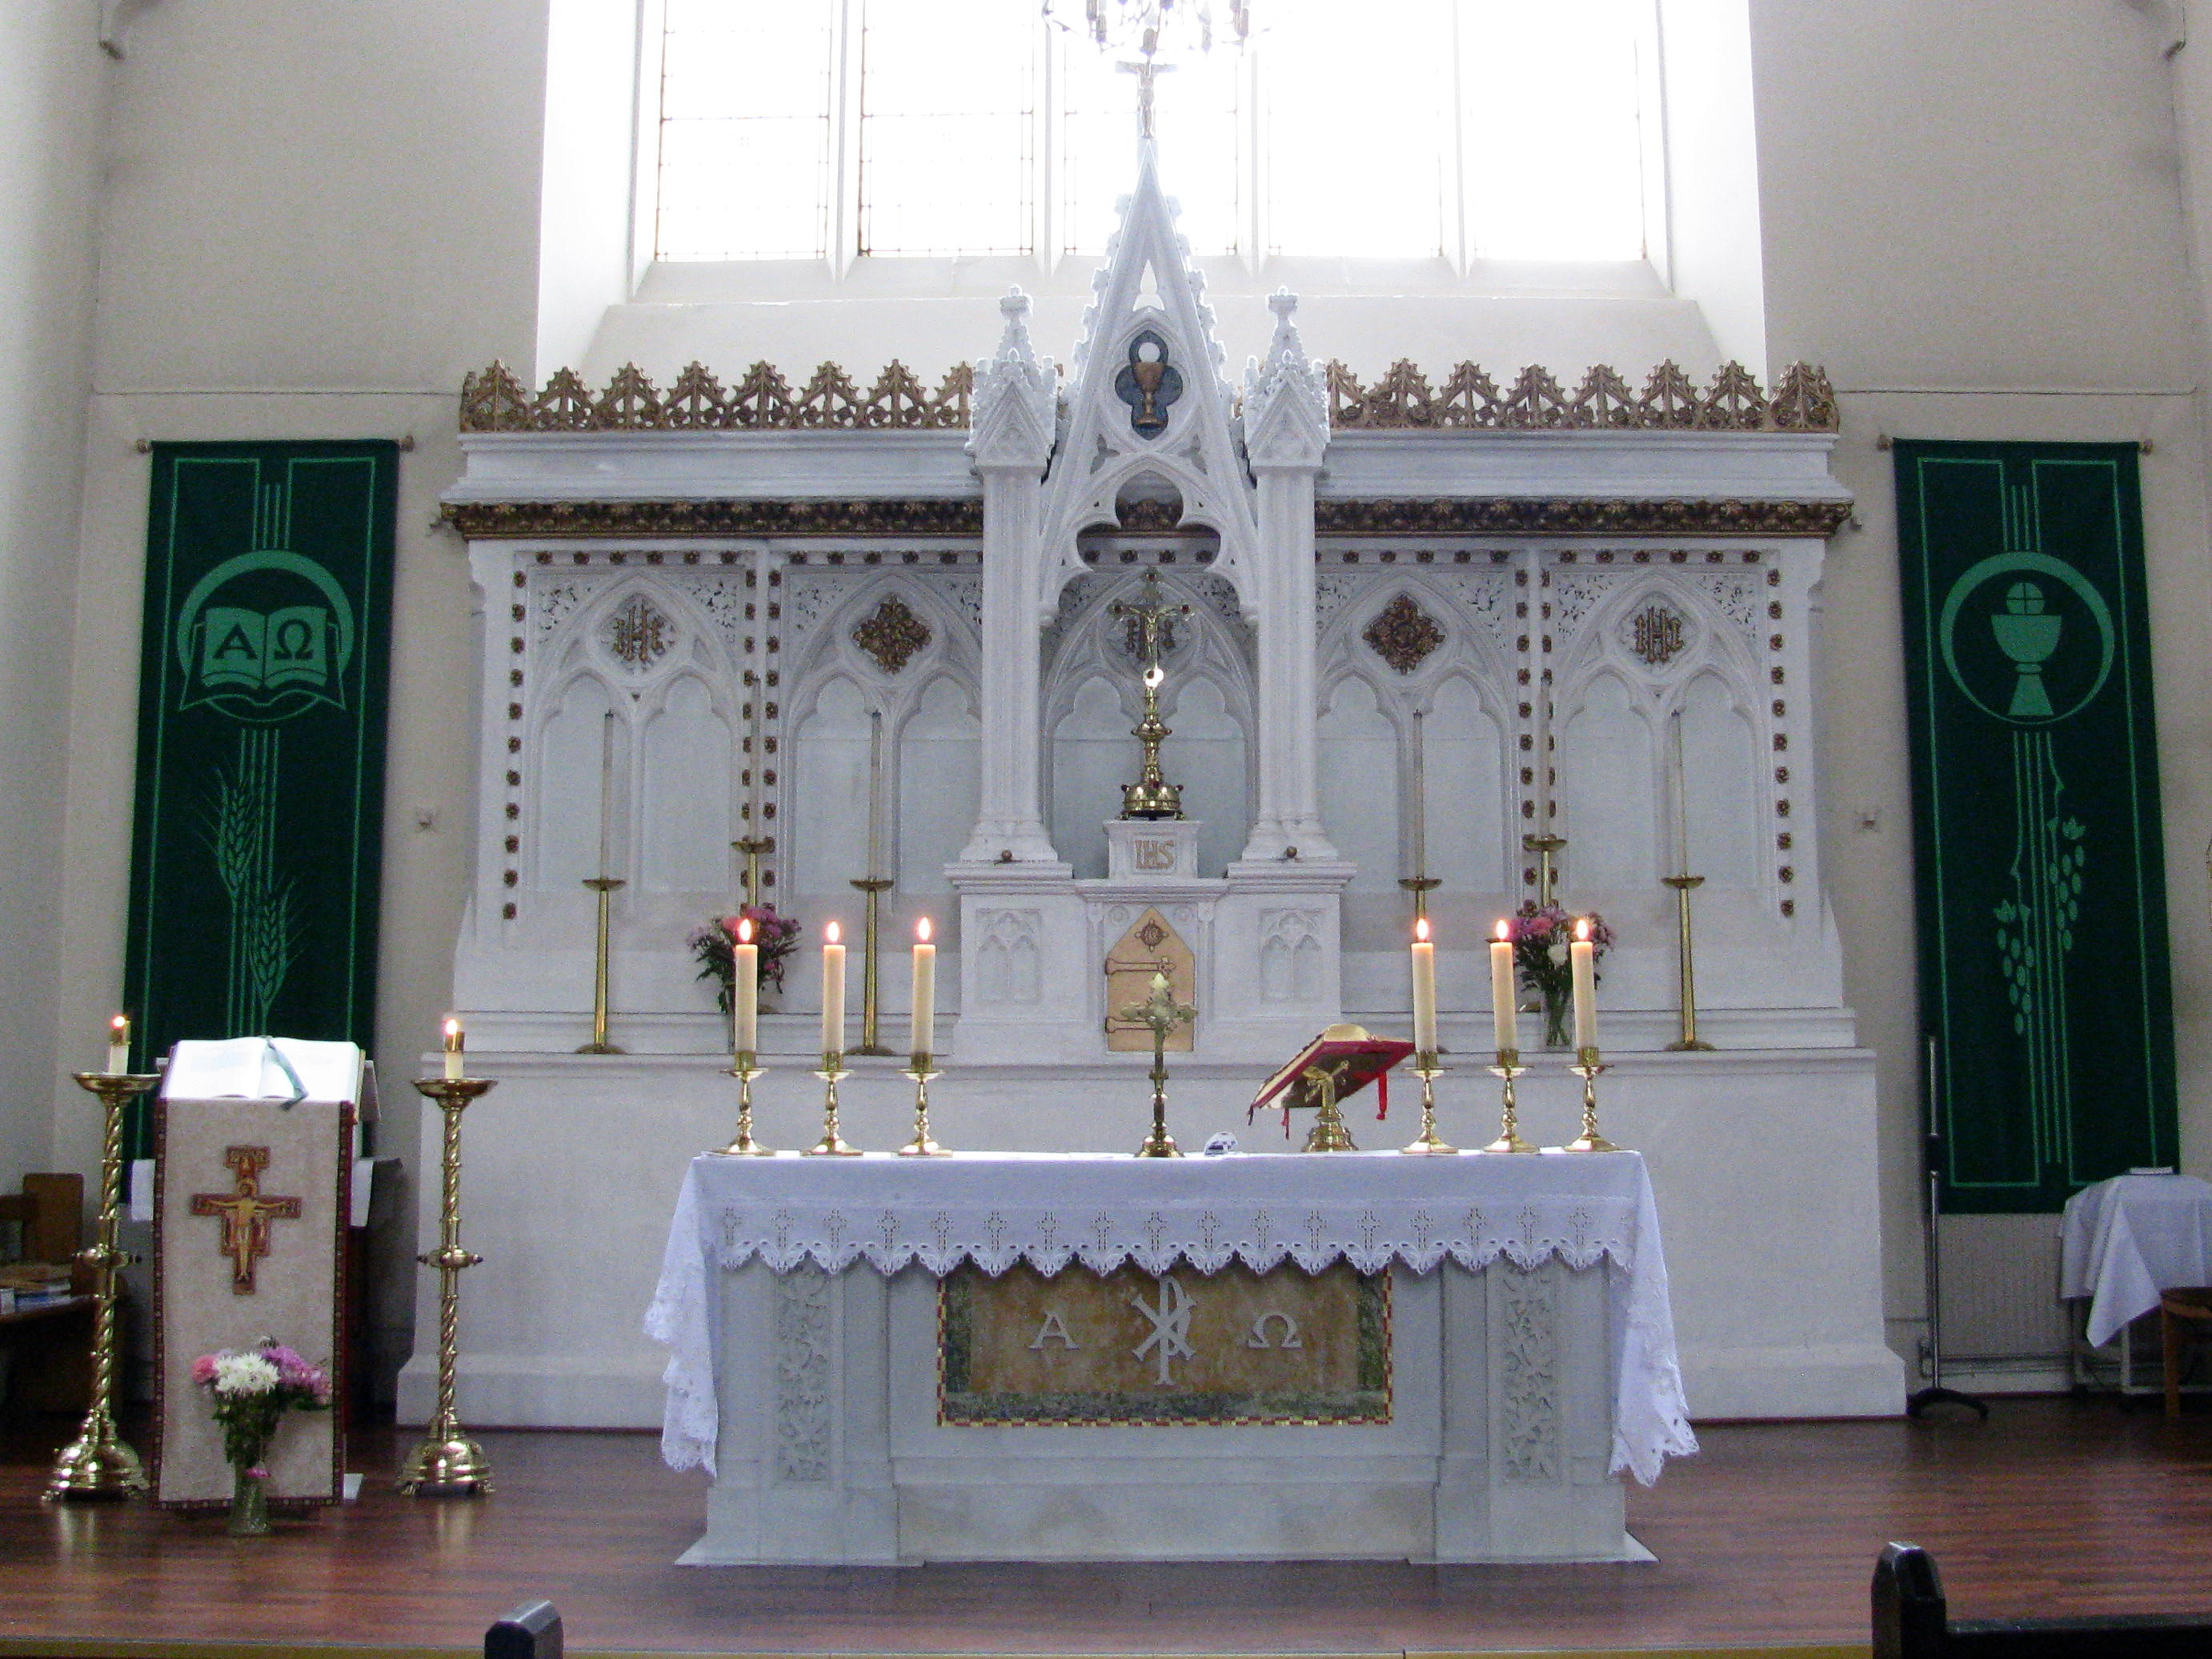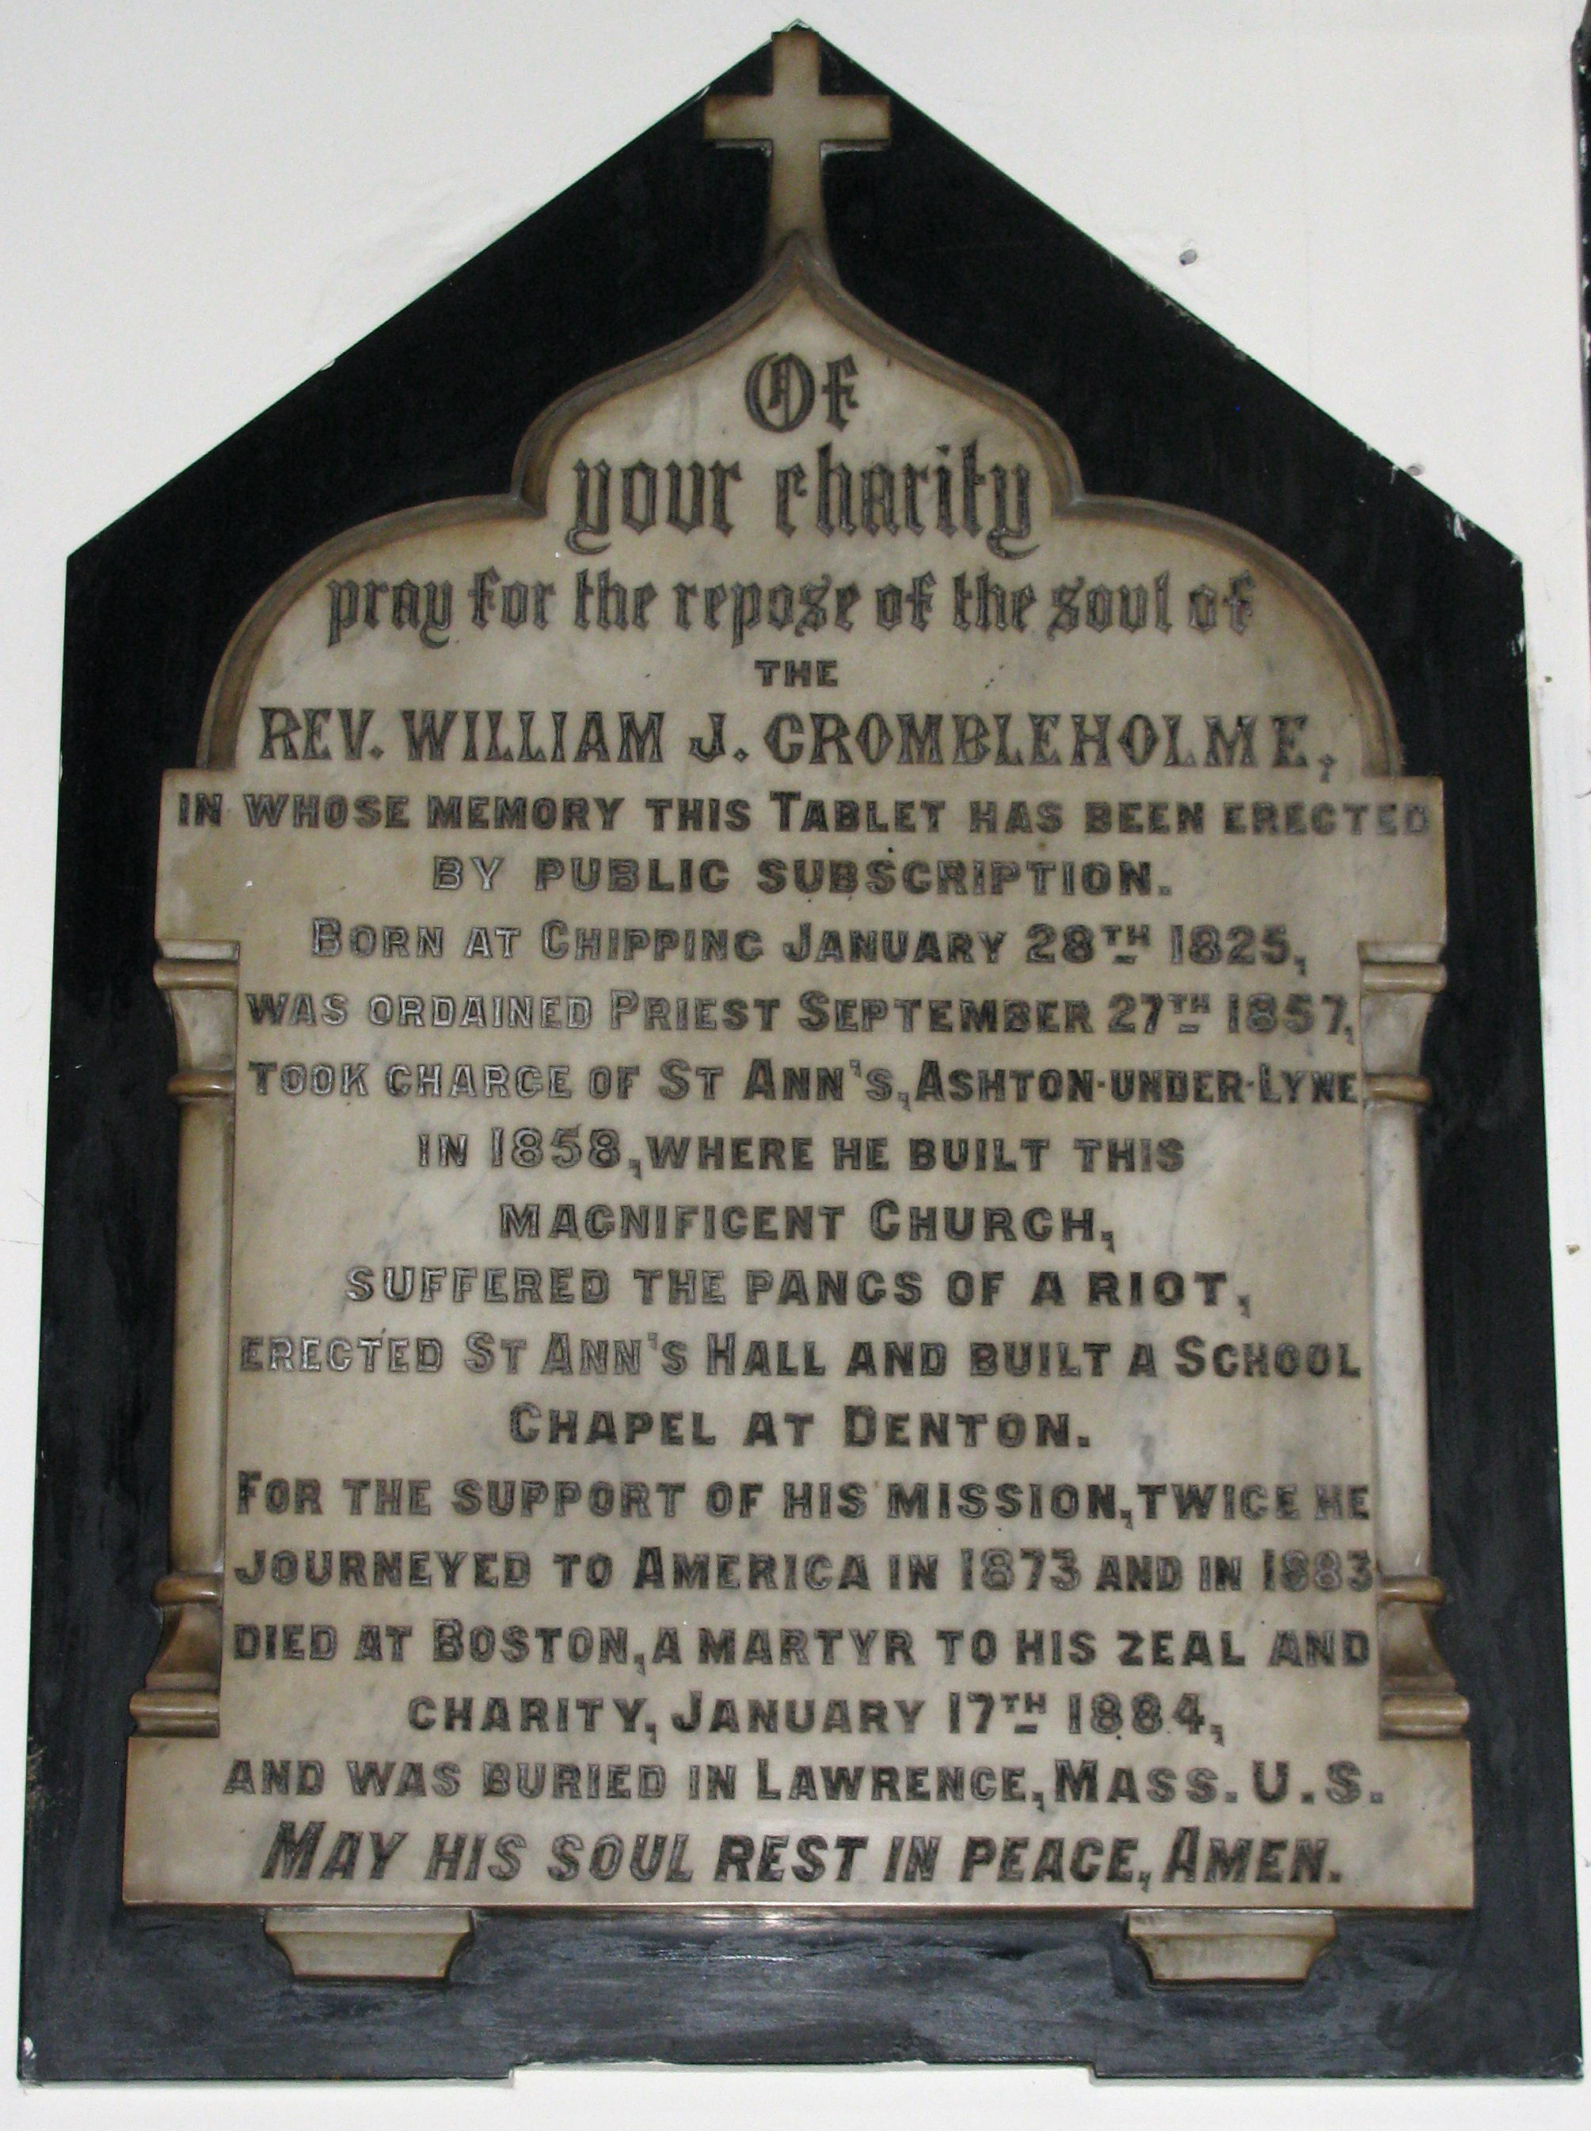

Explore our church including areas normally closed to the public. Take a closer look at the stained glass, statuary and devotional items including the Stations of the Cross. Artefacts from the now closed St Mary’s (Ashton) and St Paul’s (Guide Bridge) will be on display. In the adjacent Parish Centre displays will include items not normally on view, plus commemorations of the life of Fr William Crombleholme, who built the church, and the 1868 Murphy Riots during which the church was badly damaged by a violent mob. Light refreshments will be available in the Parish Centre. Children's activity sheets will be provided.

Essential information
We are a short walk from Ashton town centre and the bus and railway stations, at the junction of Burlington Street and Cavendish Street. The balcony is accessible only by a flight of steps.

Contact for further information
Bob Hayes - E: st.ann.rc-hods@tesco.net - T: 07840 807 462

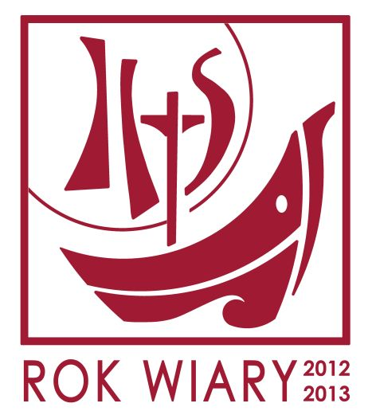 Europejskie Dni Dziedzictwa 

